Taxi-Masr project specs

An open-source crowd-sourced mobile-web taxi review service

C:\Program Files\Microsoft Office\MEDIA\CAGCAT10\j0212957.wmf

# Introduction

This is the specs document for a web application targeted to mobile devices. The application allows users to rate and read information on taxis that they ride. Information include the behavior of the taxi driver (polite or rude), driving style (slow, normal, aggressive) … etc. It’s a way of telling the taxi rider what to expect in her ride, and to optionally allow her to rate her experience with that taxi.

In addition to ratings, a safety measure is also implemented, where the user can optionally let the application send an email to a friend of hers (or her father/husband … etc.) to let him know of her location, what taxi did she take and at what time. This is a safety measure that might help save someone in case of a kidnapping attempt.

On the long term, as more and more crowd-sourced data is collected, a database of taxis in Alexandria (or any other city that this web application is targeting) would be built, leading to valuable information such as best and worst taxis, aggregated statistics on the overall status of taxis in Alexandria and the forward trends for this status, … etc. We could later implement some sort of a reward scheme where the best taxis would be able to obtain tags from the website to demonstrate their ratings.

# Technology

Technologies used for this application are HTML5 (for location awareness), PHP 5 and CodeIgniter, MySQL. The web site is mainly targeted to mobile devices and is therefore optimized for tiny touch screens, with adaptive widths, large buttons … etc. This application is a project built by the ITI students to implement the skills they learnt from an 18-hours CodeIgniter course held during the period from 27 March 2013 to 3 April 2013. The project is published with an open-source license, and hosted on GitHub to allow other interested developers to contribute to it.

# Database ERD

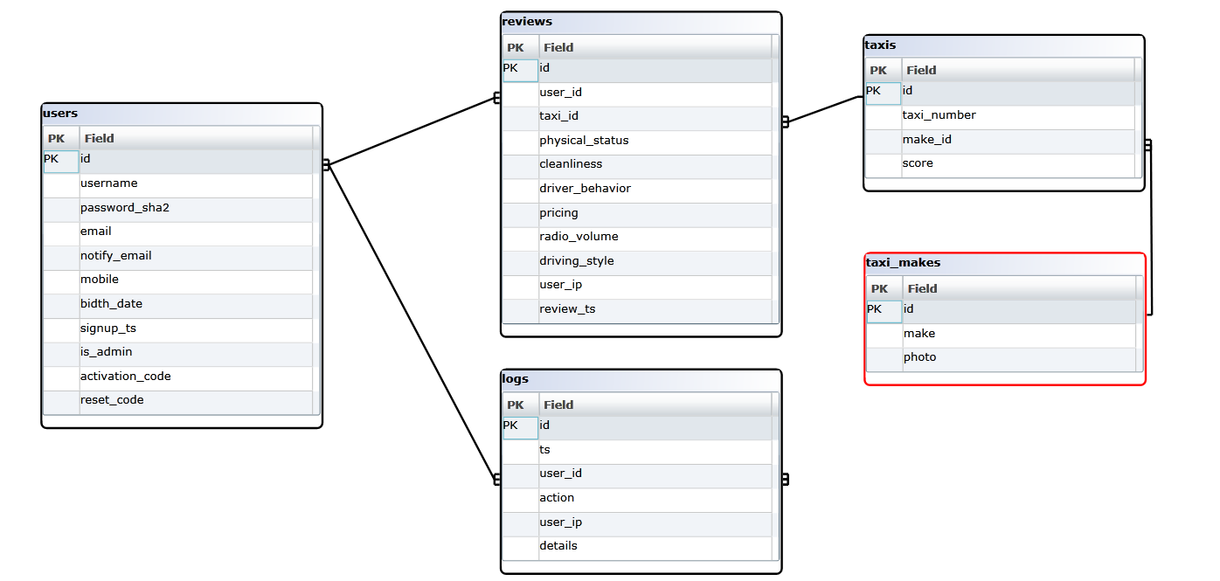

## Use cases

1. Aly is a 14 year-old kid that rides a taxi to go home after a private lesson that ends by 9:00pm. Aly’s father is always worried about him. Now, Aly can visit the site from his mobile after taking the taxi, enter the taxi number and click on the “Send notification” button (Aly is already registered and logged to the site – his login cookie lasts for one year so that he doesn’t have to log in every time he visits the site). The site then sends an email to Aly’s father that reads something like this: “قام على بركوب تاكسى رقم س ف م 2 3 4 5 الآن ... يمكنك الاطلاع على تقييم الجمهور لهذا التاكسى عبر موقع تاكسى مصر”. Aly’s father is now less-worried and he knows what to look for if Aly ever gets in trouble – God forbids.
2. Samar is a college student and she’s always nervous when taking a taxi. She learns about Taxi-Masr. So, she visits the site, clicks on “Register new account” and signs up. Now, every time she gets out of her college building and finds some parked taxis waiting in front of the college walls, she can *quickly* visit the site, enter the number of each taxi in the search box and finds out whether there are any alarming reviews. She can then choose one of the taxis with a good score and ride it in comfort.
3. Galal takes a taxi to his work … the driver is rude, listening to loud music, cursing everybody, and driving aggressively. Galal is so offended by this, but he is too shy to address the driver. Now, he has the opportunity to warn others. He goes to Taxi-Masr website on his tablet, signs up, and then enters the taxi number in the search box. The search results are empty as no one reviewed that taxi before. Galal clicks on the “Add review” button, and enters his review of that taxi. His voice can now reach not only that aggressive driver, but everyone else as well.
4. Shokry is a taxi driver. He is told by a friend about Taxi-Masr. He’s curious. He decides to check his taxi reviews. So, he visits the site and searches for his taxi number. He finds 8 reviews that agree that he is a polite driver that drives in a non-aggressive style. However, most of the reviews report that his radio is loud. Shokry decides to lower the radio volume and follow the site to watch as new reviewers improve his score. The taxi score is calculated in a way that gives higher weight to more recent reviews. Therefore, as more customers review his improved behavior, his score gets higher. Shokry is proud and shares his score with his colleagues. They’re jealous and decide to follow suit and watch as their scores improve as well.

# Screens

1. **Homepage for non-logged users** (includes the taxi search form, sign up button, sign in button)
   * **home/index**
2. **Homepage for logged users** (welcome message with profile link, taxi search form)
   * **home/welcome**
3. **Empty search results page for non-logged users** (displayed in case of no matches, or in case the search returns more than one result) – includes sign up and sign in buttons so that user can log in an add the new taxi and post a review.
   * **search/not_found**
4. **Empty search results page for logged users** (displayed in case of no matches, or in case the search returns more than one result) – includes button to post a new review about that taxi (which automatically adds the taxi as a new one).
   * **search/add_taxi**
5. **Search result page for non-logged users** … shows taxi overall and detailed score, and how many reviews that taxi had. Includes sign up and sign in buttons so that user can log in and add his review.
   * **search/taxi/{taxi_id}**
6. **Search result page for logged users** … shows taxi overall and detailed score, and how many reviews that taxi had. Includes link to post a new review for that taxi and link to send email notification if that user has a notification email in his profile.
   * **search/rate_taxi/{taxi_id}**
7. **Login form** (username, password, submit button, “Forgot password” link, sign up link) … if valid login, user goes to homepage.
   * **users/login**
8. **Sign up form** (username with ajax uniqueness checker, password, password again, email) … after sign up, user is automatically signed in to homepage.
   * **users/signup**
   * **users/check_user** (ajax checker for user existence)
9. **Rate taxi page** 6 questions, each one in a separate div, one div shown at a time, and after question is answered, its div is hidden and the next question appears. When the user answers the last question, the review is submitted and a thank you page is displayed, with a link to homepage. Questions:
   * الحالة الفنية للتاكسى: جيد، إدى زوبة زقة!
   * مستوى النظافة: جيد، مقرف!
   * سلوكيات السواق: مهذب، مش محترم
   * السعر: معقول، مبالغ فيه
   * صوت الكاسيت: معقول، مزعج
   * أسلوب القيادة: بطييييئ، معقول، متهور
   * **review/rate/{taxi_id}**
10. **Notify email page:** if user has a notify email: text-area showing email message preview and the email address to be notified, and a “Send” button. If user has no notify email, warning message and link to profile editor page. After mail is sent, a confirmation message appears, with a link to homepage and link to search result page.
    * **users/notify**
11. **View profile page:** displays user profile and link to edit it, and a link to change password.
    * **users/view_profile**
12. **Edit profile page:** allows editing of user’s email, notify email, mobile#, birth date, gender, and a submit button, and a cancel button, and a link to change password. On submit: go to view profile page, with a green notification “تم تعديل بياناتك بنجاح” … on cancel, go to view profile page with no notifications.
    * **users/edit_profile**
13. **Change password page:** old password, new password, new password again, submit >> on submit, go to view profile page, with a green notification “تم تعديل كلمة السر بنجاح”
    * **users/change_password**
14. **Forgot password page:** form to enter username OR email and a submit button and a cancel button (cancel goes to login form) … on submit, generate a 15-alphanumeric reset code, concatenate current timestamp, store it to user table, send reset link to user’s email “لتعديل كلمة السر الخاصة بك فى موقع تاكسى مصر اضغط هذا الرابط .... اذا كنت لا تريد تغيير كلمة السر يمكنك تجاهل هذه الرسالة” … display confirmation link “قمنا بارسال تعليمات تغيير كلمة السر إلى بريدك المسجل لدينا” and a link to homepage.
    * **users/forgot_password**
15. **Password reset page:** if user clicks the reset link in the email (see point 14 above), the reset page checks the reset code and makes sure it exists, and is less than 24 hours old … if invalid: redirect to home page … if expired, display red warning: “عفواً لقد انتهت صلاحية هذا الرابط ... يمكنك تقديم طلب جديد لتغيير كلمة السر هنا” and a link to “Forgot password page” … if successful, display a form for entering new password, password again, submit … change user’s password and clear the “reset code” field, log user in, redirect to homepage.
    * **users/reset_password/{reset_code}**

# Logs

The logs table records the following actions:

* “send notification” when a user requests sending a notification. The details record the To address, the user coordinates, and the message contents.
* “search taxi” when a user (logged or not) searches for a taxi .. details record the taxi number and the number of matching records
* “add review” when a user adds a taxi review. Details record the review id, taxi score before review, taxi score after review.
* “sign up” when a user submits a sign up form … details include the user id and sign up info.
* “sign in” when a user signs in successfully
* “failed login” when a user tries and fails to sign in. Details include the user id and the invalid password.
* “forgot password” when a user submits a password reset form. Details include the username or email entered and the reset code.
* “reset password” when a user successfully visits the reset password page. Details include the username and reset code.
* “profile edit” when a user changes his profile. Details include old profile data and new profile data.
* “change password” when a logged user changes (not resets) his password.

# Taxi score

Each new rating causes recalculation of taxi scores. Each taxi has a score for each of the six questions in the review form, and an overall score. Score should give more weight to more recent reviews to encourage taxis who are improving.